Solution for Chapter 9

9.1 (a) The half adder is implemented as:

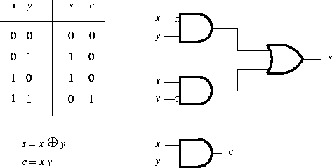

(b)
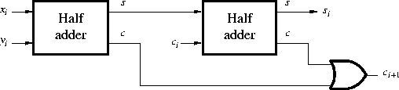

(c) The longest path through the circuit in part (b) is 4 gate delays (not including input inversions) in producing s_{i}; and the longest path through the circuit in Figure 9.2a is 2 gate delays (not including input inversions) in producing either c_{i} or s_{i}, assuming that s_{i} is implemented as a two-level AND-OR circuit.

9.9 (a)
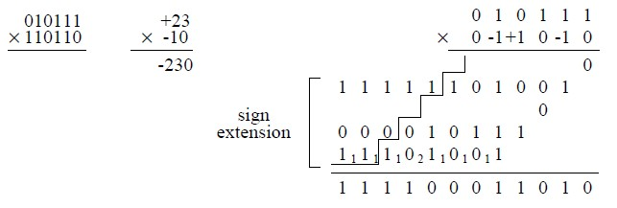

9.20 The multiplication and division charts are:

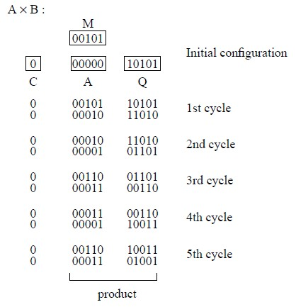

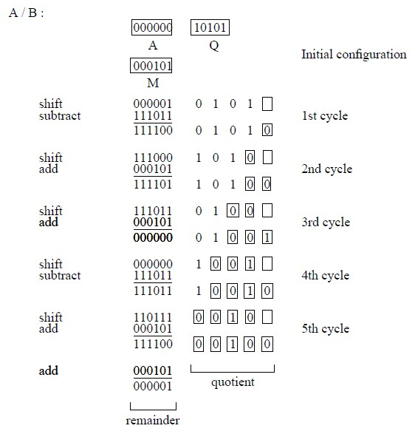

9.21 (a)
+1.7 0 01111 101101
-0.012 1 01000 100010
+19 0 10011 001100
1/8 0 01100 000000
“Rounding” has been used as the truncation method in these answers.

(b)
Because：0<E<2^5-1(31) ,1<=E<=30
So:1-15<=e<=30-15,-14<=e<=15
So:Other than exact 0 and ±infinity, the smallest numbers are ±1.000000×2⁻¹⁴ and the largest numbers are ±1.111111×2¹⁵.

(c) Assuming sign-and-magnitude format, the smallest and largest integers (other than 0) are ±1 and ±(2¹¹ - 1); and the smallest and largest fractions (other than 0) are ±2⁻¹¹ and approximately ±1.

(d)
A 0 10000 011011
B 1 01110 101010

A + B = 0 10000 000000
A– B = 0 10000 110110
A×B = 1 10000 001011
A/B = 1 10000 101110
“Rounding” has been used as the truncation method in these answers.

9.22 (a) Shift the mantissa of B right two positions, and tentatively set the exponent of the sum to 100001. Add mantissas:
(A) 1.11111111000
(B) 0.01001010101
10.01001001101

Shift right one position to put in normalized form: 1.001001001101 and increase exponent of sum to 100010. Truncate the mantissa to the right of the binary point to 9 bits by rounding to obtain 001001010. The answer is 0 100010 001001010.

(b)
Largest ≈ 2×2³¹
Smallest ≈ 1×2⁻³⁰

This assumes that the two end values, 63 and 0 in the excess-31 exponent, are used to represent infinity and exact 0, respectively.

9.32 (a) In the following answers, rounding has been used as the truncation method (see Section 9.7.2) when the answer cannot be represented exactly in the signed 6-bit format.

0.5: 010000 all cases
-0.123: 100100 Sign-and-magnitude
111011 1’s-complement
111100 2’s-complement
-0.75: 111000 Sign-and-magnitude
100111 1’s-complement
101000 2’s-complement
-0.1: 100011 Sign-and-magnitude
111100 1’s-complement
111101 2’s-complement

(b)
e = 2⁻⁶ (assuming rounding, as in (a))
e = 2⁻⁵ (assuming chopping or von Neumann rounding)

(c) Assuming that the given representation error bounds are in decimal notation:
(a) 3
(b) 6
(c) 9

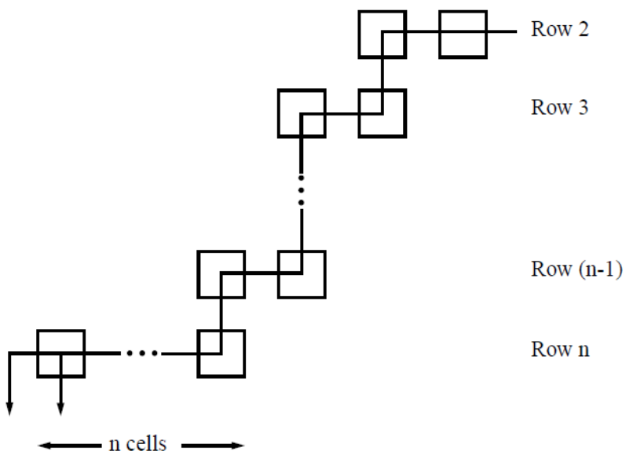
9.8 As noted in Section 9.3.1, no full adders are needed in the first row of the array because the incoming partial product PP0 is zero. The worst case delay path is shown in the following figure:
Each of the two FA blocks in rows 2 through n-1 introduces 2 gate delays, for a total of 4(n-2) gate delays. Row n introduces 2n gate delays. Adding in the initial AND gate delay for row 1 and all other cells, total delay is:
4(n-2) + 2n + 1 = 6n – 8 + 1 = 6(n - 1) - 1

